**Day 4 Assignment Hung Le**

**Chapter 6 – Programming Assignment**

**Question 1:**

|  |  |  |
| --- | --- | --- |
| **Defining table** | | |
| **Input** | **Processing** | **Output** |
| * Integer n | * Repeat the word “sunshine” n times | * Display the word “sunshine” n times |

let prompt = require('prompt-sync')();

let num = prompt("Please enter an interger number: ");

num = parseInt(num);

for (let i = 1; i <= num; i++) {

console.log("sunshine");

}

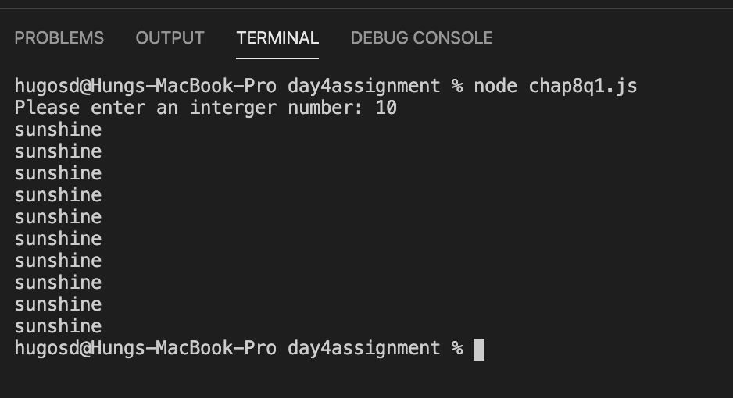

**Question 2:**

|  |  |  |
| --- | --- | --- |
| **Defining table** | | |
| **Input** | **Processing** | **Output** |
| * A phrase * An integer n | * Repeat the phrase n times | * Display the phrase n times |

let prompt = require('prompt-sync')();

let phrase = prompt("How are you?: ");

let num = prompt("Please enter an interger number: ");

num = parseInt(num);

for (let i = 1; i <= num; i++) {

console.log(phrase);

}

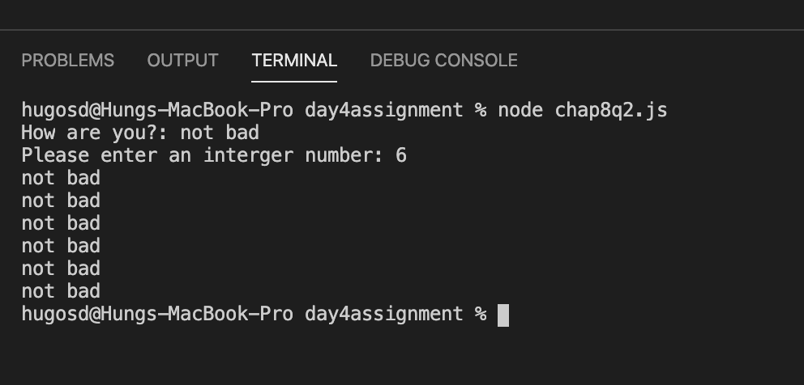

**Question 3:**

|  |  |  |
| --- | --- | --- |
| **Defining table** | | |
| **Input** | **Processing** | **Output** |
| * An integer n | * Create a for loop with i = 1, and i less than or equal to n. * Write i to log. * The loop runs i times and stop when i = n. | * Display the integers between 1 and n |

let prompt = require('prompt-sync')();

let n = prompt("Please enter an interger number: ");

n = parseInt(n);

for (let i = 1; i <=n ; i++) {

console.log(i);

}

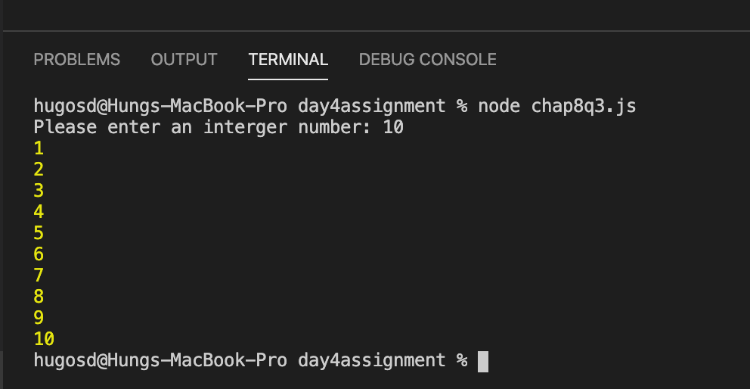

**Question 4:**

|  |  |  |
| --- | --- | --- |
| **Defining table** | | |
| **Input** | **Processing** | **Output** |
| * An integer n | * Create a for loop with i = 1, and i less than or equal to n. * Create an if statement with the condition: i % 2 not equal to 0. Divide i by 2, the remainder is not equal to 0. * Write i to log. * The loop runs i times and stop when i = n. | * Display the odd integers between 1 and n |

let prompt = require('prompt-sync')();

let n = prompt("Please enter an interger number: ");

n = parseInt(n);

for (let i = 1; i <=n ; i++) {

if(i % 2 !=0) {

console.log(i);

}

}

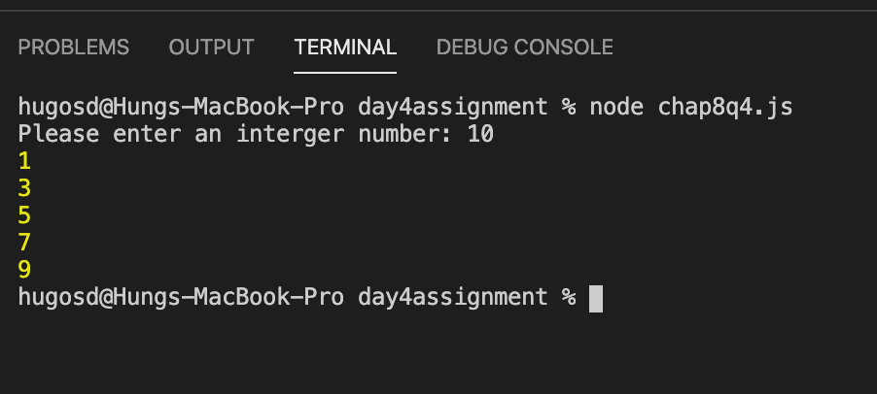

**Question 5:**

|  |  |  |
| --- | --- | --- |
| **Defining table** | | |
| **Input** | **Processing** | **Output** |
| * Nothing read from the keyboard | * Declare i = 5 * Create a for loop with j = and j is less than or equal to 12. * The computation is in the format i x j = i*j * The loop runs j times and stops when j = 12. | * Display 5 times table from 1 to 12. |

let i = 5;

for (j = 1; j<= 12; j++) {

console.log(i + " x " + j + " = " + i*j);

}

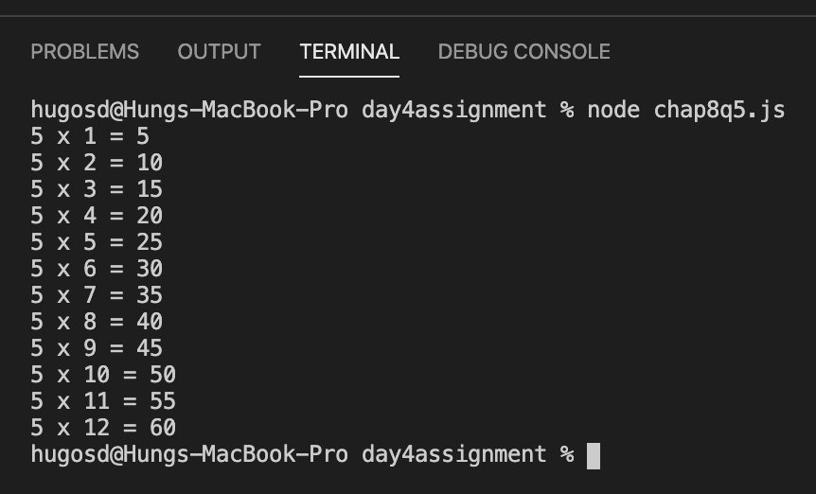

**Question 6:**

|  |  |  |
| --- | --- | --- |
| **Defining table** | | |
| **Input** | **Processing** | **Output** |
| * Nothing read from the keyboard | * Declare n =2 * Create a for loop with i = 0 and i is less than or equal to 31 * Compute the power of 2i * The loop runs i times and stops when i = 31. | * Display the powers of 2 from 20 to 231 |

let n = 2;

for (let i = 0; i <= 31; i++) {

console.log(Math.pow(n, i));

}

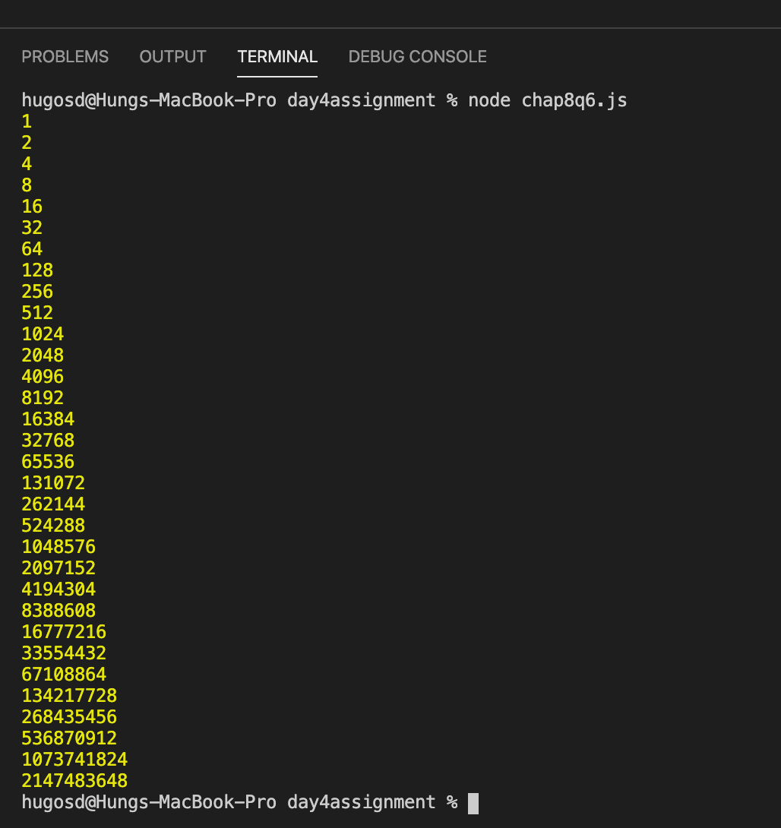

**Question 7:**

|  |  |  |
| --- | --- | --- |
| **Defining table** | | |
| **Input** | **Processing** | **Output** |
| * Nothing read from the keyboard | * Declare a = 1 * Declare b = 0 * Declare f = 0 * Write f = 0 to log * Create a loop with i = 1 and i is less than or equal to 24 * Compute the Fibonacci number with the formula f= a + b * write f to log. * Now set a = b and b = f to compute the next Fibonacci number * The loop runs i times and stop when i = 24. | * Display the first 25 Fibonacci numbers in the series from 0 to 46368 |

let a = 1;

let b = 0;

let f = 0;

console.log(f);

for(let i = 1; i <= 24; i++) {

f = a + b;

console.log(f);

a = b;

b = f;

}

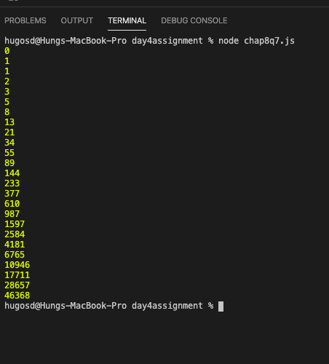

**Question 8:**

|  |  |  |
| --- | --- | --- |
| **Defining table** | | |
| **Input** | **Processing** | **Output** |
| * An integer number | * Declare variable message = a welcome and introduction phrase * Declare variable answer = 38 * Declare variable guess * Declare variable i = 1 * Create a do-while loop * Do display the message to ask for a number * Create an if statement to compare the guess number and the correct answer * Put i++ inside the if statements to compute the how many times the user tried * Keep repeating while the input number is different from the correct answer * The loop stops when the input number = correct answer = 38 | * Display the congratulations message and the correct answer and the number of times the user tried |

let prompt = require('prompt-sync')();

let message = "I'm thinking of a number between 1 and 100.\n" + "Try to guess it!\n" + "Please enter an integer between 1 and 100: ";

let answer = 38;

let guess;

let i = 1;

do {

guess = parseInt(prompt(message))

if (guess < answer) {

message = guess + " is too low. Please enter another integer: ";

i++;

}

else if (guess > answer) {

message = guess + " is too high. Please enter another integer: ";

i++;

}

} while (guess != answer);

message = guess + " is correct!";

console.log(message + " You tried " + i + " times.");

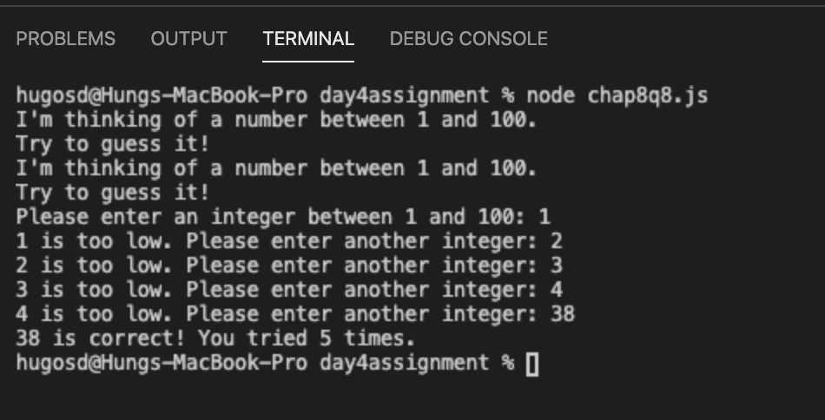

**Question 9:**

|  |  |  |
| --- | --- | --- |
| **Defining table** | | |
| **Input** | **Processing** | **Output** |
| * An integer number n | * The input number is entered * Create a for loop with i = 0, i is less or equal than n, i++ * Declare a = 2*i * Declare b = 3*i * Declare c = i*i * Declare d = i*i*i * The loop compute a, b, c, d and runs for i times and stop when i = n | * Display a table with 5 columns: n, n*2, n*3, n*n, n*n*n |

let prompt = require('prompt-sync')();

let n = parseInt(prompt("Please enter an integer number: "));

for (let i = 1; i <= n; i++) {

let a = 2 * i;

let b = 3 * i;

let c = i * i;

let d = i * i * i;

console.log(`${i} ${a} ${b} ${c} ${d}`);

}

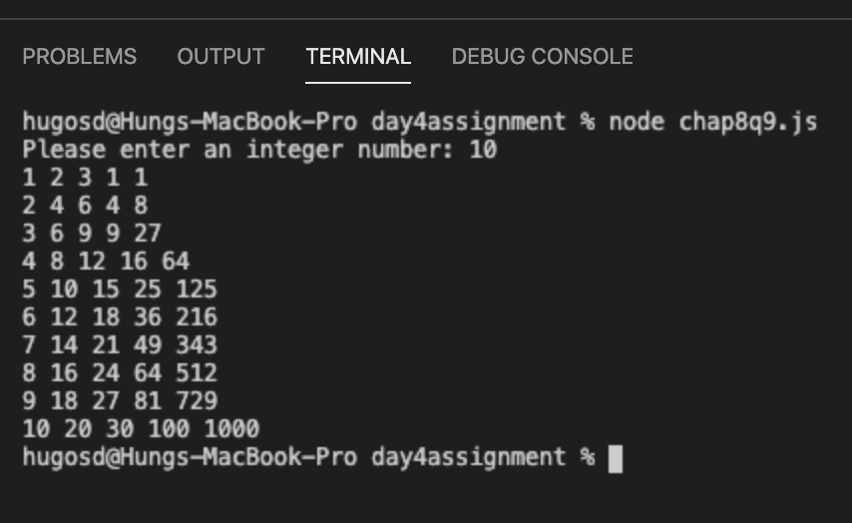

**Question 10:**

|  |  |  |
| --- | --- | --- |
| **Defining table** | | |
| **Input** | **Processing** | **Output** |
| * Nothing read from the keyboard | * Create a for loop with i = 1, and i is less than or equal 12, i++ * Declare row =”” * Create a nested loop inside with j = 1 and j is less than or equal 12, j++ * In the second loop, calculate the value of row by the formula row += i*j * The 2nd loop will run for j times and stop when j = 12. * The first loop will run the second loop i times and stop when i = 12 | * Display a 12 by 12 multiplication table |

for (i = 1; i <= 12; i++) {

let row = "";

for (j = 1; j <=12; j++) {

row += i*j + "\t";

}

console.log(row);

}

